Haorui Zhang

3/28/2019

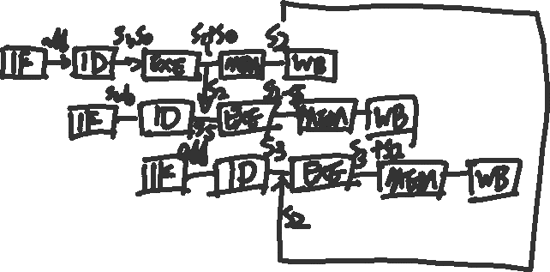

1. Sometimes the compiler can perform branch prediction. It can be accomplished in one of two ways: static prediction or dynamic prediction at run time. In a compiler, by using information, such as statistical branch probabilities collected during run time, the compiler can predict the probable outcome of conditionals, and generate instructions that try to predict correctly. One way of doing prediction is trace scheduling, which determines the sets of paths based on probabilities of branches. By determining the highest probability path, the complier can do optimizations across the entire path, rather than run it within a basic block.
   1. The size of cache is 16384 bytes (16 KB). 3 fields: valid bit = 1 bit. Tag = 18 bits, index = 12 bits, data = 4 Bytes (32 bits). The size of cache block is valid bit + tag + data = 51 bits.
   2. Read miss is valid bit = 0 (False) or the reading tag in the address passed in is not as same as the tag in the cache. It means that the data that should be read is not in the cache. In this case, memory has to be accessed to get the data based on the word address been provided. Searching through the memory to find the data based on the tag and index. Reset the cache block with same index, including the valid bit part, tag part and the data part, and return the data.